**XML Assignment 2**

**Validate a Document using Schemas**

1. Open **orders.xml** document holding data regarding customers who placed orders for a store. Figure 1 shows the *customers vocabulary* structure and Figure 2 shows a description of the elements and attributes used for the *customers vocabulary*.
2. Open **orders.xsd** document and create a schema that will validate the data entered into **orders.xml** document.

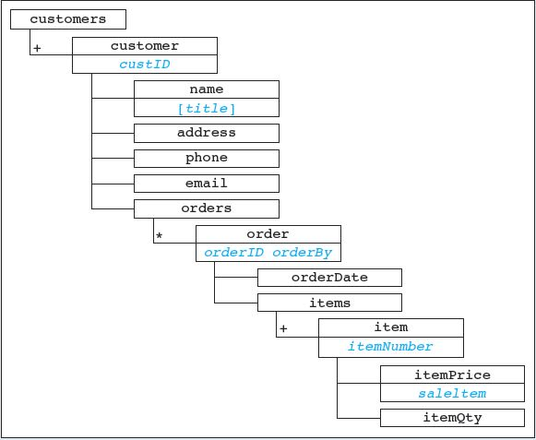

**Figure 1: Structure of the customers vocabulary**

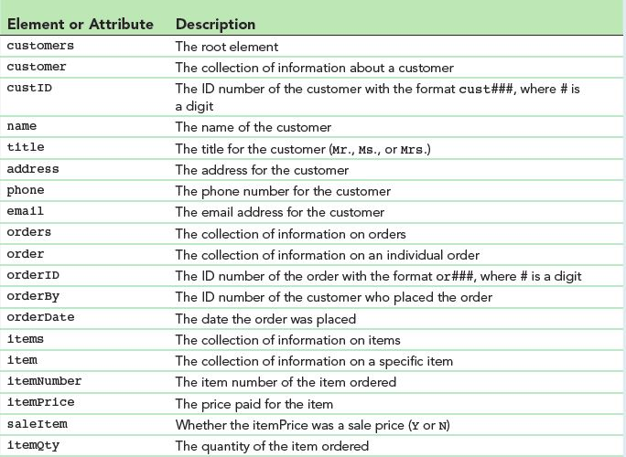

**Figure 1: The customers vocabulary**